LOGISTIC REGRESSION ANALYSIS IN R

Exercise

5. Create a logistic regression model using the “mtcars” data set with the information given

below.

The in-built data set &quot;mtcars&quot; describes different models of a car with their various engine

specifications. In &quot;mtcars&quot; data set, the transmission mode (automatic or manual) is described

by the column am which is a binary value (0 or 1). Create a logistic regression model

between the columns &quot;am&quot; and 3 other columns - hp, wt and cyl.

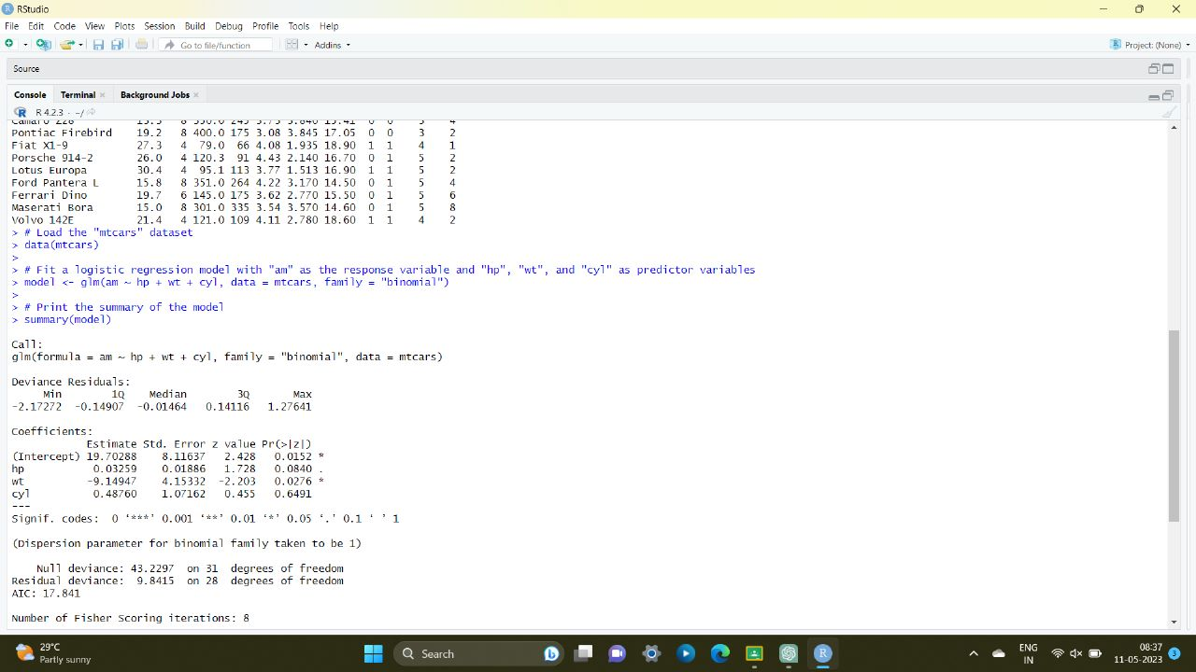

POISSON REGRESSION ANALYSIS IN R

Exercise :

6. Create a Poisson regression model using the in-built data set “warpbreaks” with

information given below.

In-built data set &quot;warpbreaks” describes the effect of wool type (A or B) and tension (low,

medium or high) on the number of warp breaks per loom. Consider &quot;breaks&quot; as the response

variable which is a count of number of breaks. The wool &quot;type&quot; and &quot;tension&quot; are taken as

predictor variables.

